Assignment 1

Problem1:

You are expected to provide a recommendation for the best model you would

recommend for classification. Which model (with parameter values) would you choose

and why?

Comment on how good your model is ? Does it overfit/underfit data ? What could you

do to improve the model?

In order to learn how parameters influence the result of MLP, I did 32 experiments with these parameters: epochs, batch size, learning rates, activation function, dropout rates, the numbers of neurons. The following table shows choosing values of these parameters.

|  |  |  |  |  |
| --- | --- | --- | --- | --- |
| epochs | batch size | learning rates | activation function | Numbers of neurons |
| 150 | 128 | 0.1 | relu | 512 |
| 200 | 256 | 0.2 | relu | 1024 |

I used for loop to generate 32 combinations with these parameters and train 32 models with these combinations. And the accuracy of the best model is 0.5509. And the following table is the parameter value of the best model:

|  |  |  |  |  |  |
| --- | --- | --- | --- | --- | --- |
| epochs | batch size | learning rates | activation function | Numbers of neurons | Dropout rates |
| 200 | 256 | 0.02 | Relu | 1024 | 0.4 |

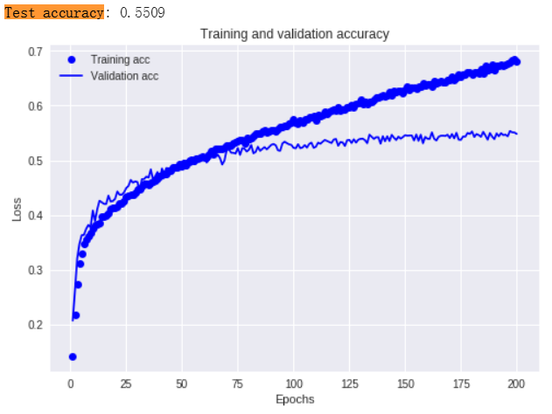

From the figure above, we can find that the model had been overfitted after 75 epochs. If we want to prevent the model overfit, we can use regularization method such as L1,L2.

We can compare the parameter of worst model and the best model of parameter to find the way to change parameters to make model better. And the following table is the parameter value of the worst model:

|  |  |  |  |  |  |
| --- | --- | --- | --- | --- | --- |
| epochs | batch size | learning rates | activation function | Numbers of neurons | Dropout rates |
| 150 | 128 | 0.01 | Relu | 512 | 0.5 |

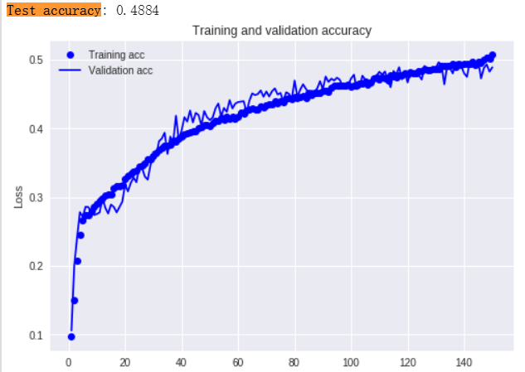

So If we want to improve the accuracy of the model, we can increase the number of epochs, neurons, batch size, learning rate. But it might have the problem of overfitting. To prevent this happen, we can use some regularization methods.